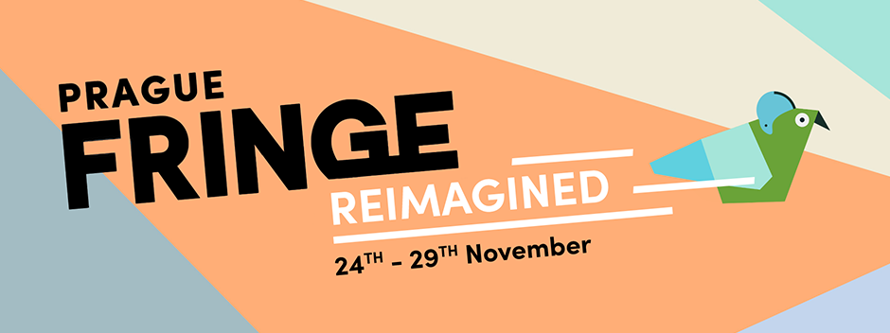

Press release - for immediate release
Thursday 12th November 2020

Prague Fringe Reimagined: Sharing the best of new Czech theatre with the world
Buckle up! A brand-new version of the world-renowned Prague Fringe Festival is here! Created as a result of, (and despite) the Coronavirus pandemic.

Puppet Theatre for all ages, Physical theatre, multi-media performance and more - this is Fringe Reimagined

This November, instead of bringing the international theatre community to the Czech Republic, Prague Fringe Reimagined will share the best of new Czech theatre with the rest of the world.

In a ‘normal’ year, the Prague Fringe is a melting pot of international theatre, with audiences, artists, and industry professionals converging in Prague for the nine-day May event. Sadly, due to the restrictions put in place to curb the spread of Coronavirus we were forced to reschedule the May festival just days before launching ticket sales. The team quickly pulled together a spontaneous digital event ‘Prague Fringe Online’ as an alternative which took place during the planned festival dates in May.

Since then, facing a severe second wave of virus cases, instead of presenting the rescheduled event in the Autumn as hoped, the Fringe team have adapted their format entirely to create ‘Prague Fringe Reimagined’. A festival of Czech theatre, performed live and streamed in high quality to international audiences around the world.

From Tuesday 24th - Sunday 29th November audiences can enjoy a hand-picked programme of the best new productions the Czech Republic has to offer - streamed right into their living rooms! The live performances will be filmed with multiple cameras and streamed in high quality via the Fringe website. Fellow festivals in the 250-strong Fringe network around the world will be sharing the content with their audiences as far away as Australia, and Fringes closer to home such as Brighton Fringe in England.

The programme includes brand-new work from recent graduates of DAMU (Academy of Performing Arts in Prague, Theatre Faculty), as well as productions from established theatre company Divadlo Líšeň from Brno, the country’s second-largest city. A variety of genres are on offer including puppetry, physical theatre and multi-media performances.

There will also be an accompanying programme of free post-show talks, virtual workshops and webinars with artists and theatre industry professionals, both from the Czech Republic and abroad.

Fringe Founder and Director Steve Gove said “Despite everything that 2020 has thrown at us, we’re determined to continue to adapt and persevere with our entirely reimagined version of the Fringe this November.”
“It’s been a long and challenging year for our team, as well as for our artists and fellow Fringe organisers all over the world. We’re really excited to have the opportunity to present such an interesting and exciting selection of Czech work to our international audience!”

Thanks to a grant supporting digital art from the Czech Ministry of Culture and funding from the Avast Foundation and The City of Prague, the streams will be available to watch on the Prague Fringe website entirely for free - no complicated logins, subscriptions or payment required.

All performances are either non-verbal, in English, or performed in Czech with English subtitles.

The programme of live shows is available now at www.praguefringe.com.

Prague Fringe Reimagined
Tuesday 24th - Sunday 29th November 2020
www.fringe.cz / www.praguefringe.com

###

Contact for press: press@fringe.cz
Show photos available on request.

